**Name: Shreya Agrawal**

**Class: A5_B3**

**Roll no.: 38**

**DAA PRACTICAL 4**

***Code:***

def maximum_sum_subarray(arr, constraint):

if not arr:

print("No feasible subarray")

return

def max_cross_sum(arr, mid):

left_sum = -999999

s = 0

left_index = mid

for i in range(mid, -1, -1):

s += arr[i]

if s > left_sum:

left_sum = s

left_index = i

right_sum = -999999

s = 0

right_index = mid + 1

for i in range(mid + 1, len(arr)):

s += arr[i]

if s > right_sum:

right_sum = s

right_index = i

cross_sum = left_sum + right_sum

print("Left Sum:", left_sum, "Right Sum:", right_sum, "Cross Sum:", cross_sum)

return cross_sum, arr[left_index:right_index + 1]

def divide(arr):

if len(arr) == 1:

if arr[0] <= constraint:

return arr[0], arr

else:

return -999999, []

mid = len(arr) // 2

left_sum, left_subarray = divide(arr[:mid])

right_sum, right_subarray = divide(arr[mid:])

cross_sum, cross_subarray = max_cross_sum(arr, mid - 1)

max_sum = left_sum

max_subarray = left_subarray

if right_sum > max_sum:

max_sum, max_subarray = right_sum, right_subarray

if cross_sum > max_sum:

max_sum, max_subarray = cross_sum, cross_subarray

if max_sum > constraint:

return -999999, []

return max_sum, max_subarray

max_sum, max_subarray = divide(arr)

if max_sum <= 0:

print("No feasible subarray")

else:

print("Maximum Sum:", max_sum)

print("Subarray:", max_subarray)

print("Test 1:"); maximum_sum_subarray([2, 1, 3, 4], 5)

print("Test 2:"); maximum_sum_subarray([2, 2, 2, 2], 4)

print("Test 3:"); maximum_sum_subarray([1, 5, 2, 3], 5)

print("Test 4:"); maximum_sum_subarray([6, 7, 8], 5)

print("Test 5:"); maximum_sum_subarray([1, 2, 3, 2, 1], 5)

print("Test 6:"); maximum_sum_subarray([1, 1, 1, 1, 1], 4)

print("Test 7:"); maximum_sum_subarray([4, 2, 3, 1], 5)

print("Test 8:"); maximum_sum_subarray([], 10)

print("Test 9:"); maximum_sum_subarray([1, 2, 3], 0)

print("Test 10:"); maximum_sum_subarray(list(range(1, 21)), 50)

**Output:**

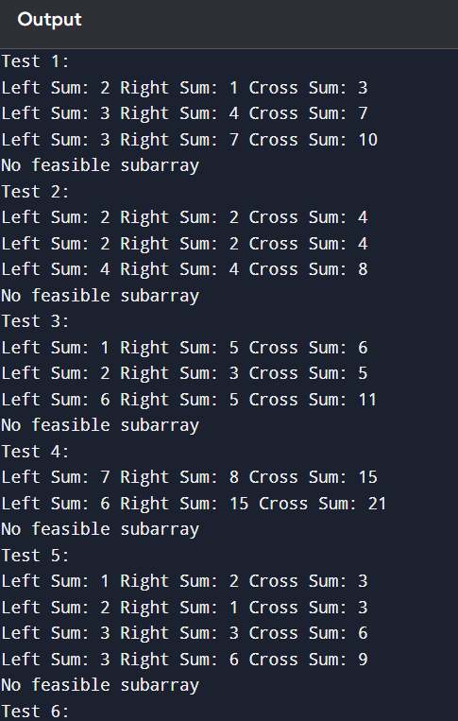

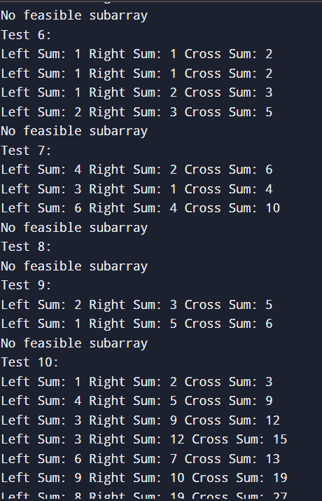

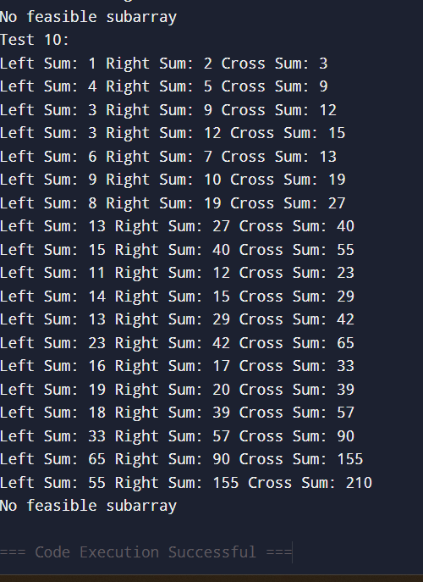

**LEETCODE:**

int maxSubArray(int* nums, int numsSize) {

int current_sum = nums[0];

int max_sum = nums[0];

for (int i = 1; i < numsSize; i++) {

// Either extend current subarray or start new subarray

if (current_sum + nums[i] > nums[i])

current_sum = current_sum + nums[i];

else

current_sum = nums[i];

if (current_sum > max_sum)

max_sum = current_sum;

}

return max_sum;

}

